**~~ Objective~~**

The objective of this project is to help the bright future of this era by providing the best facility. They can have a smooth environment and platform to explore more. Other than that, there would be less paperwork just because whole system will be computerized. People sitting at home, or in office, or at anywhere around the world, they can feed their brains. One needs not to stand in the queue just for a small query. One needs not to go to the library just to enquire about book and be afraid that all of the hard work may go in vain. He or she can just enquire about the book at enquiry desk, if available then go, otherwise have a good day.

**~~Introduction~~**

Library is a home for various kinds of books in large amount. The books can be related to history, fiction, biography, novel category, etc. The books play an important role in a human’s life from the time of their birth.

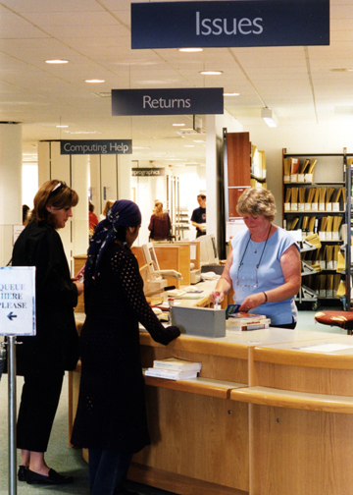A *Library Management System* is a collection of different entities - books, librarian, accountant, customer, student or reader, etc. It is a centralized place where all the information related to different types of books can be found.

The project undertaken does the automation of the **‘LIBRARY MANAGEMENT SYSTEM’** in the organization. It’s built on the performance, reliability, quality and ease of use. It also include a number of features that further eshtablish it as a better GUI application. ‘LIBRARY MANAGEMENT SYSTEM’ is a system having Menu Derived User Interface. It contains the vital data and informations reguarding book, issue and customer details. Administrator of the project can enter new book and issue details, display all/specific book and issue details and modify book and issue details. The software is developed in C++.

The main reason of developing this software is to reduce the workload and to provide the ease of use to accomplish the desired task along with better service to the customers and society.

**~~System Requirements~~**

For the **‘**LIBRARY MANAGEMENT SYSTEM’ to execute properly the minimum requirements are:

* Hardware Requirements:
* Processor: Intel 486 Processor
* Ram: 8 MB
* Hard Disk: 20 GB
* Monitor: 14” Coloured LED
* Keyboard: US Layout
* Mouse
* Printer, to print required documents of the program
* Software Requirements:
* Operating System: Windows XP
* Turbo C++, for execution of the program
* Ms Word, for presentation of output

**~~Header Files Used~~**

For the **‘**LIBRARY MANAGEMENT SYSTEM’ to execute properly the header files used are:

* FSTREAM.H, for file handling, cin and cout
* IOMANIP.H, for formatting the output screen
* STRING.H, for string handling
* CONIO.H, for clrscr() and getch() functions
* STDIO.H, for standard I/O operations
* MATH.H, for mathematical operations

**~~ Files Generated~~**

For the **‘**LIBRARY MANAGEMENT SYSTEM’ to execute properly the following files are created:

* C++ Source File
* DASS BOOK WORLD.cpp
* Execution File
* dassbo~1.exe
* Text Files
* BOOK.TXT
* ISSUE.TXT
* Object File
* dassbo~1.obj
* CSM File
* tcwdef.csm